Prepare a model for strength of concrete data using Neural Networks

|  |
| --- |
| concrete <- read.csv("C:/Users/sahil/Downloads/concrete.csv")  > View(concrete)  > library(readr)  > summary(concrete)  cement slag ash water superplastic  Min. :102.0 Min. : 0.0 Min. : 0.00 Min. :121.8 Min. : 0.000  1st Qu.:192.4 1st Qu.: 0.0 1st Qu.: 0.00 1st Qu.:164.9 1st Qu.: 0.000  Median :272.9 Median : 22.0 Median : 0.00 Median :185.0 Median : 6.400  Mean :281.2 Mean : 73.9 Mean : 54.19 Mean :181.6 Mean : 6.205  3rd Qu.:350.0 3rd Qu.:142.9 3rd Qu.:118.30 3rd Qu.:192.0 3rd Qu.:10.200  Max. :540.0 Max. :359.4 Max. :200.10 Max. :247.0 Max. :32.200  coarseagg fineagg age strength  Min. : 801.0 Min. :594.0 Min. : 1.00 Min. : 2.33  1st Qu.: 932.0 1st Qu.:731.0 1st Qu.: 7.00 1st Qu.:23.71  Median : 968.0 Median :779.5 Median : 28.00 Median :34.45  Mean : 972.9 Mean :773.6 Mean : 45.66 Mean :35.82  3rd Qu.:1029.4 3rd Qu.:824.0 3rd Qu.: 56.00 3rd Qu.:46.13  Max. :1145.0 Max. :992.6 Max. :365.00 Max. :82.60  > normalize <- function(x){  + return((x-min(x))/(max(x)-min(x)))  + }  > concrete_norm<-as.data.frame(lapply(concrete,FUN=normalize))  > summary(concrete_norm)  cement slag ash water superplastic  Min. :0.0000 Min. :0.00000 Min. :0.0000 Min. :0.0000 Min. :0.0000  1st Qu.:0.2063 1st Qu.:0.00000 1st Qu.:0.0000 1st Qu.:0.3442 1st Qu.:0.0000  Median :0.3902 Median :0.06121 Median :0.0000 Median :0.5048 Median :0.1988  Mean :0.4091 Mean :0.20561 Mean :0.2708 Mean :0.4774 Mean :0.1927  3rd Qu.:0.5662 3rd Qu.:0.39775 3rd Qu.:0.5912 3rd Qu.:0.5607 3rd Qu.:0.3168  Max. :1.0000 Max. :1.00000 Max. :1.0000 Max. :1.0000 Max. :1.0000  coarseagg fineagg age strength  Min. :0.0000 Min. :0.0000 Min. :0.00000 Min. :0.0000  1st Qu.:0.3808 1st Qu.:0.3436 1st Qu.:0.01648 1st Qu.:0.2664  Median :0.4855 Median :0.4654 Median :0.07418 Median :0.4001  Mean :0.4998 Mean :0.4505 Mean :0.12270 Mean :0.4172  3rd Qu.:0.6640 3rd Qu.:0.5770 3rd Qu.:0.15110 3rd Qu.:0.5457  Max. :1.0000 Max. :1.0000 Max. :1.00000 Max. :1.0000  > train <- concrete_norm[1:773,]  > test <- concrete_norm[774:1030,]  > library(neuralnet) # regression  > library(nnet) # classification  > concrete_model <- neuralnet(strength~cement+slag+ash+water+superplastic+coarseagg+fineagg+age,data = train)  > plot(concrete_model) |
|  |
| |  | | --- | | > | |

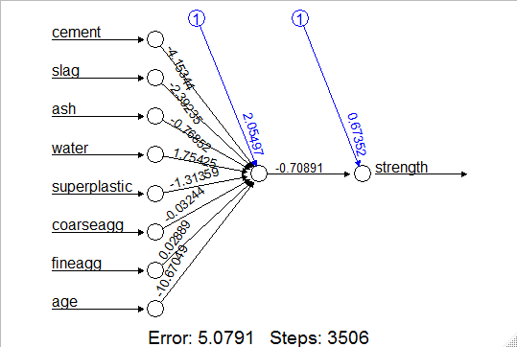

|  |
| --- |
| model_result <- compute(concrete_model,test[1:8])  > str(model_result)  List of 2  $ neurons :List of 2  ..$ : num [1:257, 1:9] 1 1 1 1 1 1 1 1 1 1 ...  .. ..- attr(*, "dimnames")=List of 2  .. .. ..$ : chr [1:257] "774" "775" "776" "777" ...  .. .. ..$ : chr [1:9] "" "cement" "slag" "ash" ...  ..$ : num [1:257, 1:2] 1 1 1 1 1 1 1 1 1 1 ...  .. ..- attr(*, "dimnames")=List of 2  .. .. ..$ : chr [1:257] "774" "775" "776" "777" ...  .. .. ..$ : NULL  $ net.result: num [1:257, 1] 0.327 0.467 0.237 0.673 0.463 ...  ..- attr(*, "dimnames")=List of 2  .. ..$ : chr [1:257] "774" "775" "776" "777" ...  .. ..$ : NULL  > predicted_strength <- model_result$net.result  > cor(predicted_strength,test$strength)  [,1]  [1,] 0.8062164  > plot(predicted_strength,test$strength) |
|  |
| |  | | --- | | > | |

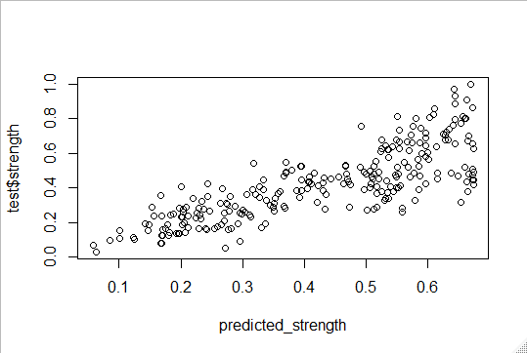

model_5<-neuralnet(strength~cement+slag+ash+water+superplastic+coarseagg+fineagg+age,data= concrete_norm,hidden = 5)

> plot(model_5)

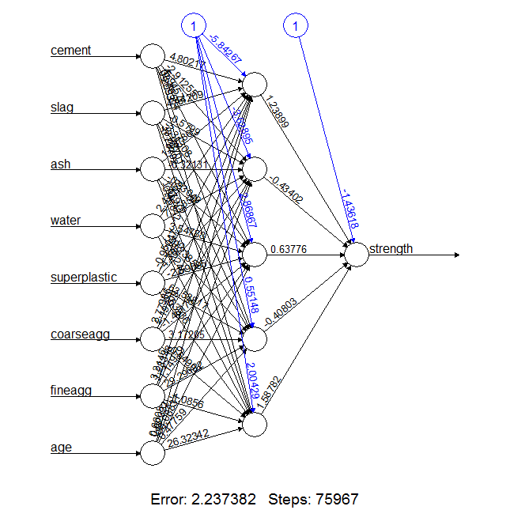

model_5_res<-compute(model_5,test[1:8])

> pred_strn_5<-model_5_res$net.result

> cor(pred_strn_5,test$strength)

[,1]

[1,] 0.9440269

plot(pred_strn_5,test$strength,col="blue")

